**LAB 2 REPORT**

**Objective:**

To assemble basic logic gates – AND OR NOT XOR using an Arduino as input and verify is NOT and AND are logically equivalent to NOR (by Demorgan’s) and NOT and OR are logically equivalent to NAND (Demorgan’s)

**Electronic Components Used:**

Digital Testing kit, wires, NOT GATE (7404 IC), AND GATE (7411 IC), OR GATE (7432 IC), NOR GATE (7402 IC), NAND GATE (7400 IC), XOR GATE (7486 IC) , Arduino Uno

**Reference Circuit:**

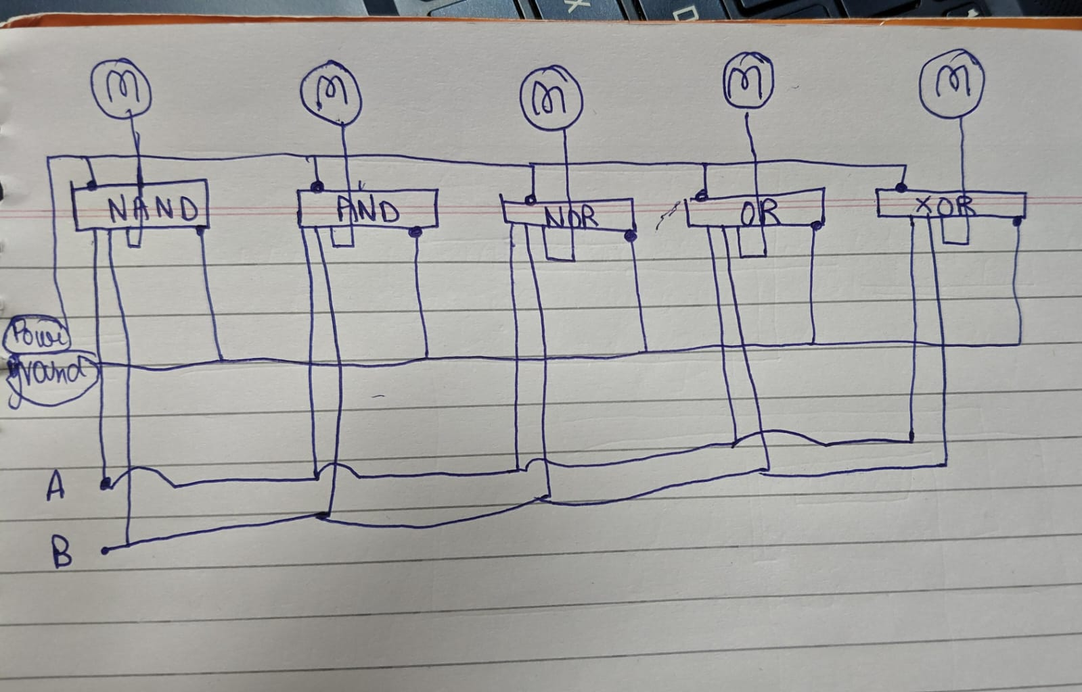

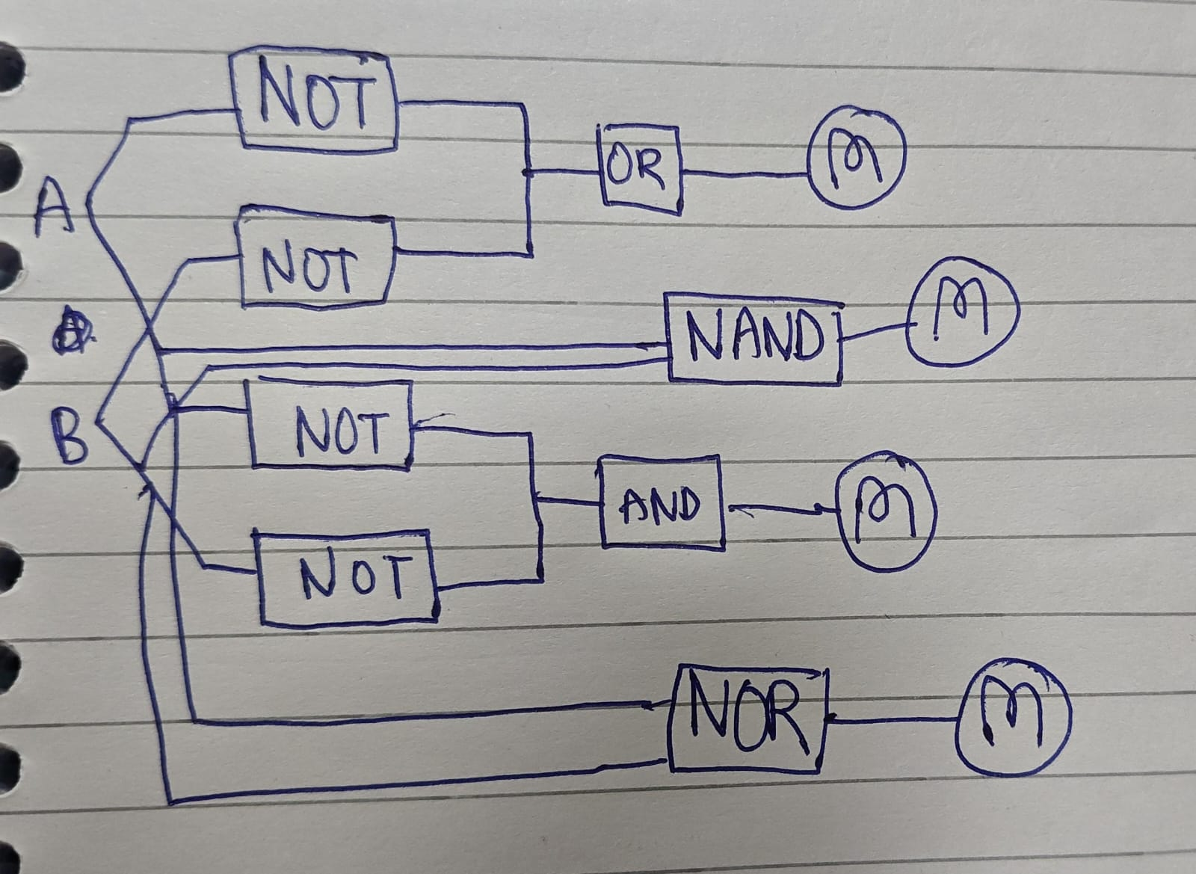

**Procedure:**

1. Implementation of LOGIC gates :
   1. First connect the Arduino to your computer
   2. Open Arduino IDE and click on select board. Select Arduino UNO in the USB port you connected the Arduino to in step a
   3. Test the connection by compiling and uploading a simple print statement
   4. In the breadboard part of the digital testing kit attach a 7404 IC (NOT GATE) , AND GATE (7411 IC), OR GATE (7432 IC) and XOR GATE (7486 IC) to the centre of the board.
   5. Connect the ground pin (7th pin) of the 7404, 7411, 7432, 7486 IC to the GND port on the Arduino Uno
   6. Connect the power pin (14th pin) of the 7404,7411, 7432, 7486 IC to the 5V port on the Arduino Uno
   7. Now in the void setup define an output pin (7 pin of Arduino UNO) -> we will give power to gates using this pin
   8. Now in void setup define another output pin for binary operators (8 pin of Arduino UNO) -> we will also use this pin to give output.
   9. Now connect the input pin of 7404, 7411, 7432, 7486 IC to the 7th pin of the Arduino using the series in breadboard.
   10. Now connect input 2 pin of 7411, 7432, 7486 IC (except the NOT gate) to the 8th pin of the Arduino using another series in the breadboard.
   11. Connect the corresponding output pin of in the 7404, 7411, 7432, 7486 IC to the LEDS present in the digital tester kit.
   12. Now in the void loop we can give either HIGH or LOW to each of the 8 and y7 pin to get different outputs
   13. Put a delay of 1000 milliseconds.
2. Verify Demorgan’s Laws:
   1. First connect the Arduino to your computer
   2. Open Arduino IDE and click on select board. Select Arduino UNO in the USB port you connected the Arduino to in step a
   3. Test the connection by compiling and uploading a simple print statement
   4. In the breadboard part of the digital testing kit attach a 7404 IC (NOT GATE) , AND GATE (7411 IC) in one side in the centre of the board. And a NOR gate (7402 IC) on the other side of the breadboard.
   5. Connect the ground pin (7th pin) of the 7404, 7411, 7402 IC to the GND port on the Arduino Uno
   6. Connect the power pin (14th pin) of the 7404,7411, 7402 IC to the 5V port on the Arduino Uno
   7. Now in the void setup define an output pin (7 pin of Arduino UNO) -> we will give power to gates using this pin
   8. Now in void setup define another output pin for binary operators (8 pin of Arduino UNO) -> we will also use this pin to give output.
   9. Now connect the input pin of 7404(NOT) and 7402(NOR) IC to the 7th pin of the Arduino using the series in breadboard.
   10. Now connect input 2 pin 7404(NOT) (another input for compliment of second variable) and 7402(NOR) IC to the 8th pin of the Arduino using another series in the breadboard.
   11. Connect the corresponding output pins of in the 7404 as the input pins of the 7411(AND) pins
   12. Connect the output of the 7411 (AND) IC and the 7402(NOR) IC to the LED present in the digital testing kit.
   13. Now in the void loop we can give either HIGH or LOW to each of the 8 and 7 pin to replicate all the 4 possible combinations of values from these pins
   14. After all the 4 types of inputs we will notice that the output for the LED connected to the AND and the NOR gate is the same.
   15. Repeat the experiment to verify the other Demorgan’s law by replacing AND (7411) with OR (7432) and NOR (7402) with NAND (7400)

**TinkerCAD Simulation**:

*Link to tinker cad creation part a:* [*https://www.tinkercad.com/things/cJLcGH6JfsS-lab2a*](https://www.tinkercad.com/things/cJLcGH6JfsS-lab2a)

*Link to tinker cad creation part b:* [*https://www.tinkercad.com/things/dNLZxfLE6hi-lab2b*](https://www.tinkercad.com/things/dNLZxfLE6hi-lab2b)

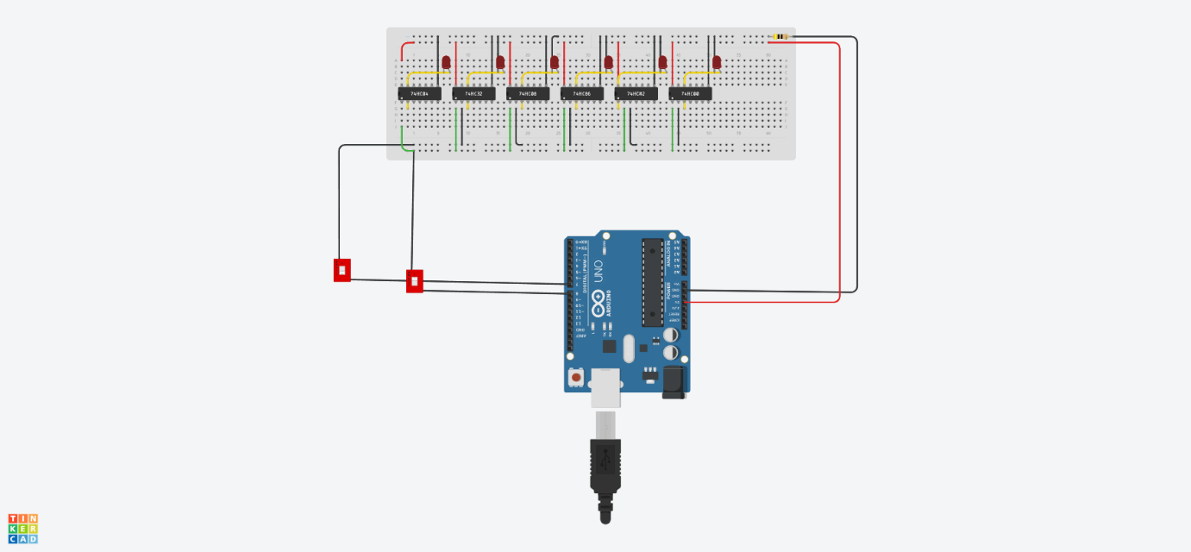

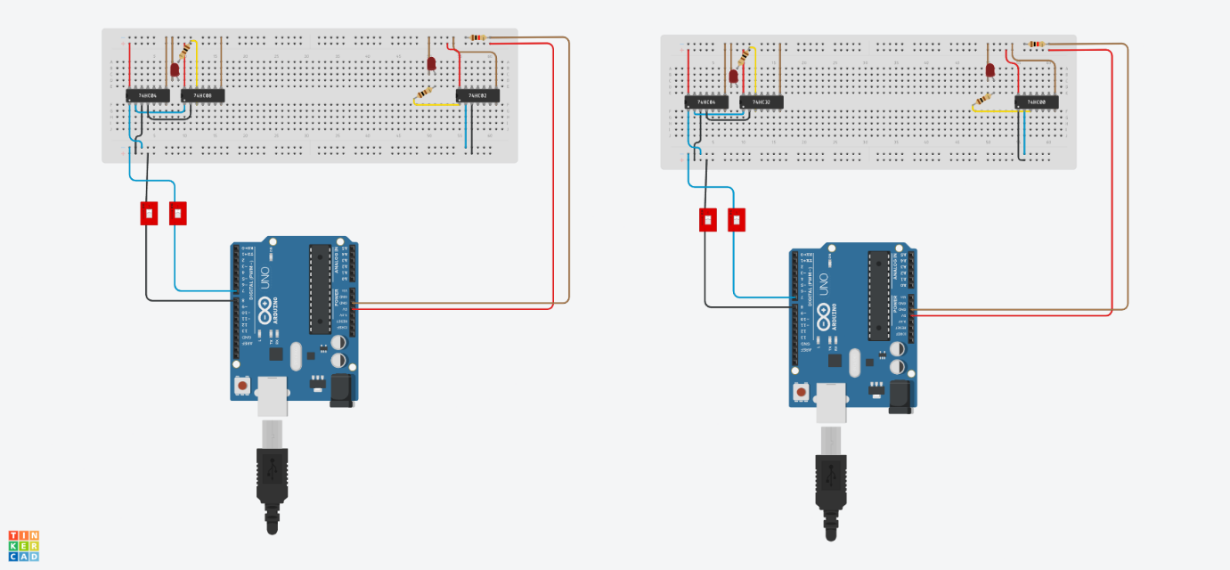

**Code:**

In tinker cad connection to switch made so instead of all 4 cases separately can be done using 1 code and changing value of switch

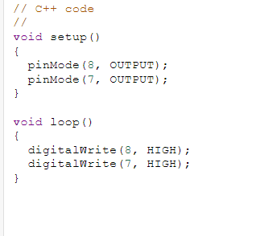

**Lab Images:**

